**Bryan Jackson**

**The Temple Inn and Suites**

**Site planning document**

**Site Purpose**: The temple inn and suites is a hospitality company that is focused on providing short term lodging for temple patrons. The website will be designed to facilitate customer booking of suites and will inform patrons about, and enhance our services.

**Target Audience**: Our target customers are temple patrons and temple workers. We are looking to attract anyone who travels to visit temples outside their home temple district, and those who wish to attend the temple while traveling for business or pleasure.

**Site Map**:

Home

Services

Reservation

Temple

Full Time Missionary

Reception

**Color Scheme**:

**Typography:**

Headings and Titles: Calibri

Text: Arial

**Wireframe Sketches:**

Full Size Screen

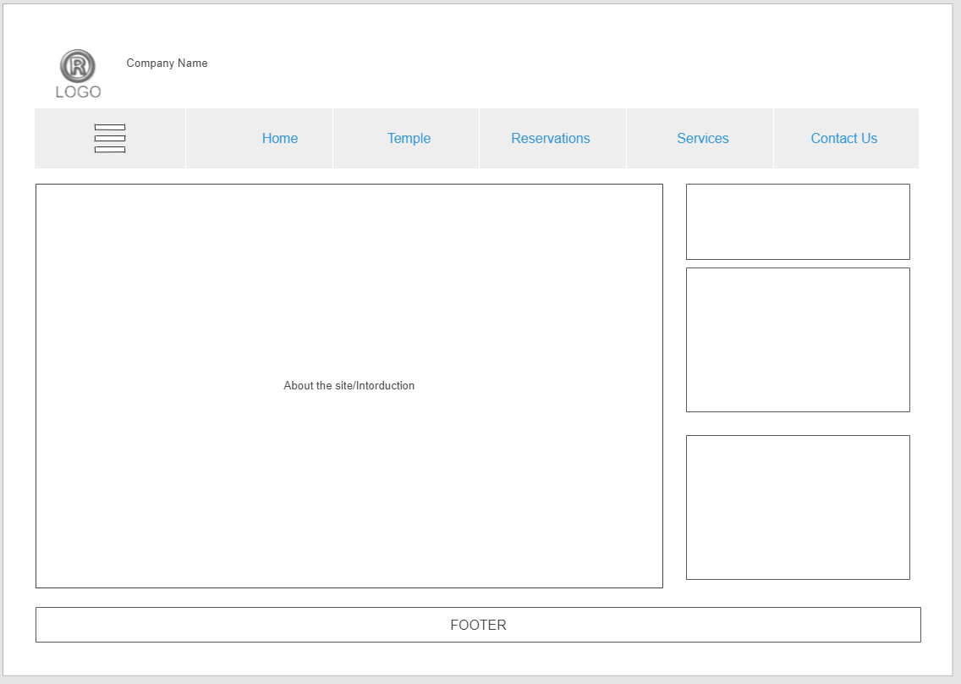

Mid Size Screen

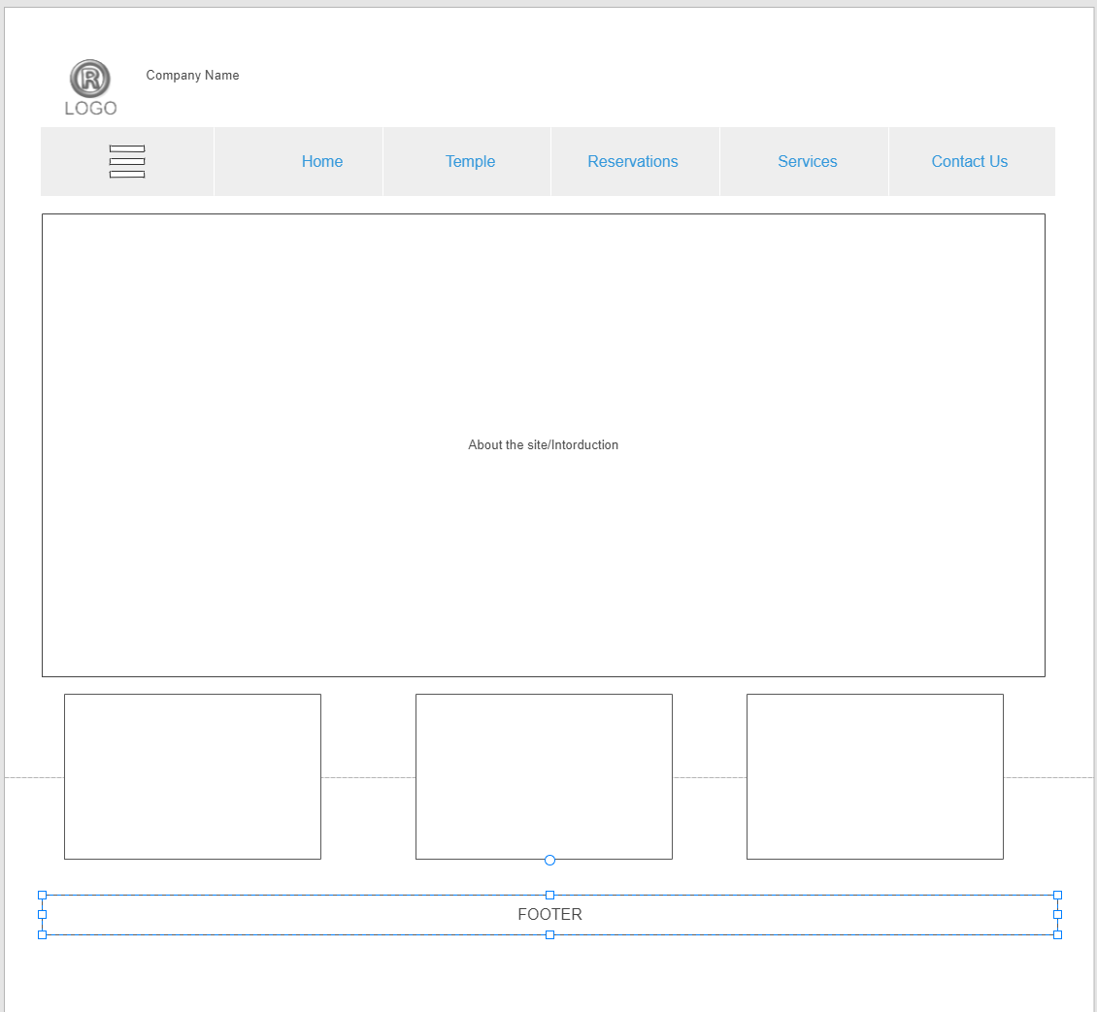

Small Size Screen

